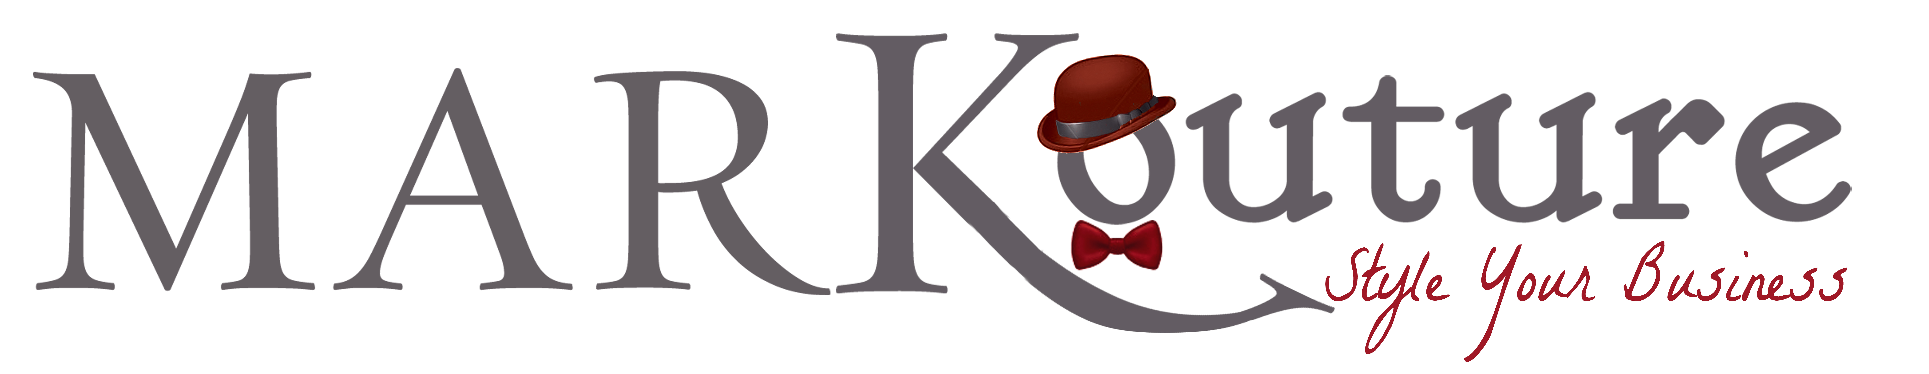

LOGO DESIGN AND BRAND IDENTITY QUESTIONNAIRE

General Information:

Company Name(s):

Contact Name(s):

Website(s):

Length of Time in Business:

Location:

Describe the basic products/services you provide:

Brand Identity:

What is your MISSION STATEMENT?

What are you company’s CORE VALUES?

What is the VISION of your company?

What adjectives would you use to describe your company’s PERSONALITY?

What VOICE will you use to talk about your products and/or services?

What is your TAGLINE?

What type of IMAGERY do you use in your marketing?

What VALUE do you bring to your customers?

What is your primary COMPETITIVE ADVANTAGE?

What makes your company UNIQUE?

Logo Preferences:

What do you envision your logo to be like?

What elements are important to include in your logo (specific themes or components)?

When people look at your logo, what message do you want it to convey?

COLORS you would like to incorporate.

COLORS you would like to avoid using.

FONT styles you would like to incorporate (block, sans serif, script, western, retro, modern, etc).

FONT styles you would like to avoid using.

If you are redesigning your logo, what do you like/dislike about your current logo?

Where will you be using your logo on (select all that apply)?
____Print
____Web/Online
____Promotional Products
____Branded Apparel
____Signage
____Other (please specify):

Anything else we should know?

